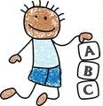
EPAG CHILD CAREGIVER HANDOUT

Playing & learning:
Playing is a very important part of every child’s day. It is crucial for their social, emotional, physical, and brain growth. It is their way of learning about the world.

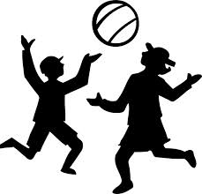
Playtime should include:

- Singing songs
- Dancing, clapping, etc.
- Talking with the infant / toddler
- Playing games (peek-a-boo, rolling the ball, “I spy with my little eye,” etc.)

An important idea for playing is to play with the child – not at the child. Let playtime be an interactive and shared activity. While children are playing, it is good to offer positive support – saying things like “Good job!” or “Well done!” and clapping your hands when they do something special, like grab a toy (for an infant) or sing a song (for a toddler).

CHILDCARE TIP: When a child starts to cry or fuss, you can often distract them by singing a song – and the crying stops.
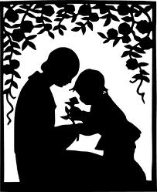
Lots of talking:
Keep the day lively by talking regularly to the children. Give names to objects, toys, animals, and people the children see; point out body parts (foot, hand, head, ear, mouth, etc.); and explain what you are doing. For example: “Hi baby. I think it’s time to change your diaper. Let’s open your clothes. Oh yes – it’s a poopoo diaper. Here’s the new diaper. We’re going to get you all nice and clean.” This helps the baby to learn the language and understand the world around him/her.

6 playtime songs
If You’re Happy and You Know It  “If you're happy and you know it, clap your hands,  If you're happy and you know it, clap your hands,  If you're happy and you know it,  Then your face will surely show it,  If you're happy and you know it, clap your hands!”  2) stomp your feet  3) shout “Hooray!”  etc. | I’m a Little Teapot  “I'm a little teapot,  Short and stout,  Here is my handle,  Here is my spout,  When I get all steamed up,  Hear me shout,  Tip me over and pour me out!”
One, Two, Buckle My Shoe  “One, two, buckle my shoe,  Three, four, knock the door,  Five, six, pick up sticks,  Seven, eight, lay them straight,  Nine, ten, a big fat hen!” | Twinkle, Twinkle Little Star  “Twinkle, twinkle, little star,  How I wonder what you are,  Up above the world so high,  Like a diamond in the sky,  Twinkle, twinkle, little star,  How I wonder what you are.”
Itsy Bitsy Spider  “The itsy bitsy spider crawled up the water spout,  Down came the rain, and washed the spider out,  Out came the sun, and dried up all the rain,  And the itsy bitsy spider went up the spout again.” | Head and Shoulders, Knees and Toes  “Head and shoulders, knees and toes, knees and toes,  Head and shoulders, knees and toes, knees and toes,  Eyes and ears and mouth and nose,  Head and shoulders, knees and toes, knees and toes!”

